Sunday, 6 September 2026, postcard

The Play that Goes Wrong and Balthazar

Well, drat. This was the morning David was going to get up for breakfast—but no. He had a terrible night (food poisoning, he thinks) and got no sleep. He called me to arrange to meet for lunch and went back to bed.

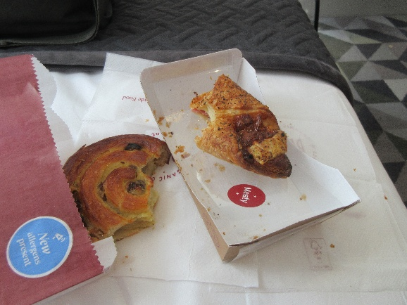
So it was back to Pret A Manger. Deliveries are later on Sundays, so they were completely out of sandwiches, but I scored a hot ham-cheese-and-tomato croissant and a pain aux raisins.
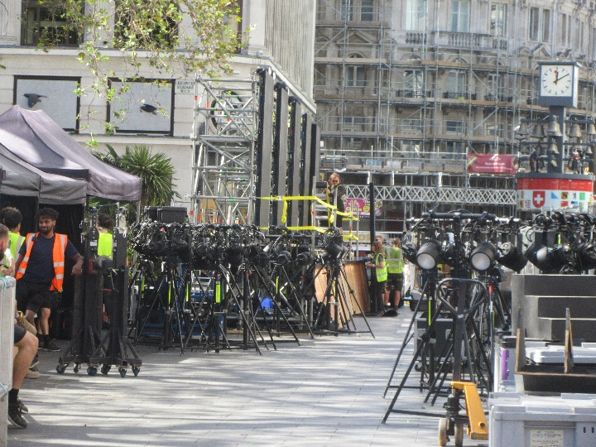
A long strip of space along our side of the square was blocked off with portable woven-wire fencing, with a private security person stationed every 10 feet or so along it. Inside, guys in hard hats were setting up what looked like temporary bleachers. A movie premier is apparently imminent. The Odeon (the one with Batman on top) bills itself as "the house of premiers." Maybe celebrities will be in evidence. I wonder whether it will be a very long red carpet coming in from a side street or whether they'll let the limos drive right up to the door.

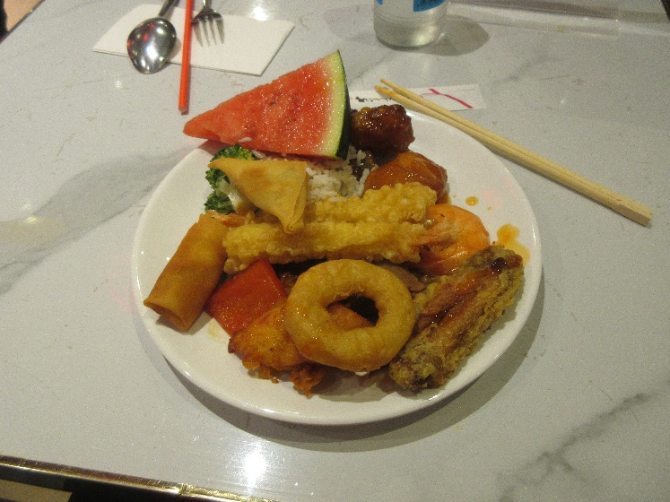
About 11:30 am, David said his stomach wasn't ready for lunch, and I was on my own again. Chinese buffet, I guess. We'll confer again later about whether he can make it to the 3 pm matinée and/or our 6:30 pm reservation at Balthazar. Poor guy,

The Chinese buffet was about what you'd expect at that location and for that price, but not bad. The tempura-fried prawns were good, as were the sweet-and-sour sauce, spring rolls, spicy samosas, and (surprisingly) the broccoli. The staff were all Chinese, but none of the customers was, and I was the only one in the place using chopsticks. I had to ask for them.

Our 3 pm matinée of The Play That Goes Wrong was scheduled to end at 5:05 pm, so I had made reservations at Balthazar, a French restaurant in nearby Covent Garden, but the earliest they could take us was 6:30 pm. David decided to skip the play, but he said he'd meet me by taxi at Balthazar's (promising to call me if he decided he couldn't make it).

The play was indeed very funny, reminiscent of Noises Off, but involving a play staged by amateurs rather than seasoned professionals. Much slapstick, missing of cues, and failure of props and scenery.

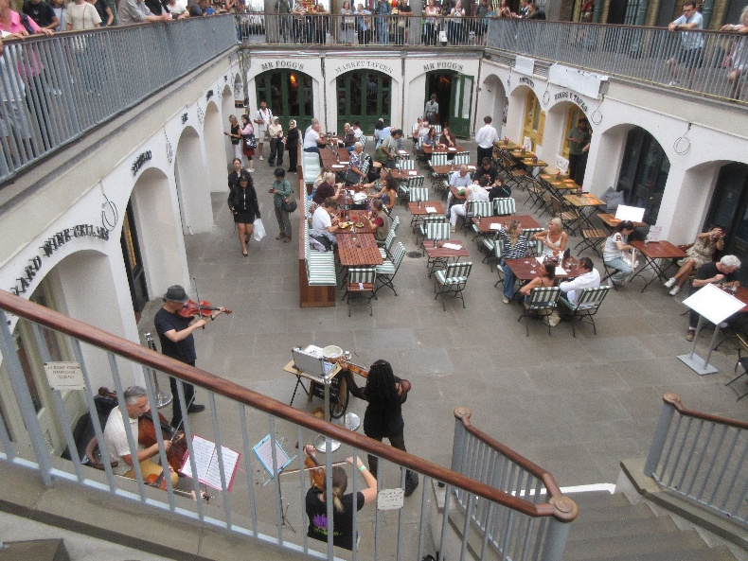
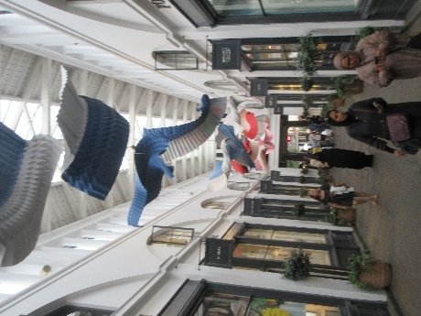
I got out of the theater and killed some time by strolling around Covent Garden, waiting for his call. About 5:40 pm, I presented myself at the restaurant, explained the situation, and was offered a table immediately at which I could wait for David! He called as I was walking to the table saying he was on his way. Through a truly amazing display of ignorance and incompetence (on the part of the hotel staff, not David), he couldn't get a taxi and had to settle for one of those silly, neon-bedecked, music-blaring, overpriced urban bicycle rickshaws. Its operator was also ignorant and incompetent—the closest point to the restaurant that he recognized was The Lion King (i.e., the Lyceum Theatre), several blocks short of the restaurant. David had to call me for directions from there.

Brief diatribe: The drivers of regulation black London cabs know everything and everywhere. You can just tell them where you're going and they'll take you there. The same is not true of other taxis, rickshaws, or hotel desk staff. They are utterly unable to pull up a map of any location in London without starting with the postal code. This isn't the first time we've encountered this problem, so I carefully looked up and wrote the postal code on the note I gave David to help him find the restaurant. But the hotel staff were baffled by a 7-character postal code, even though the hotel's own postal code is now 7 characters. The rickshaw guy was baffled as well, which is why David finally had to say it was within a few blocks of The Lion King. Have these people never heard of Google?! (Or MapQuest or any other half-decent mapping or navigation program?) Dunces.

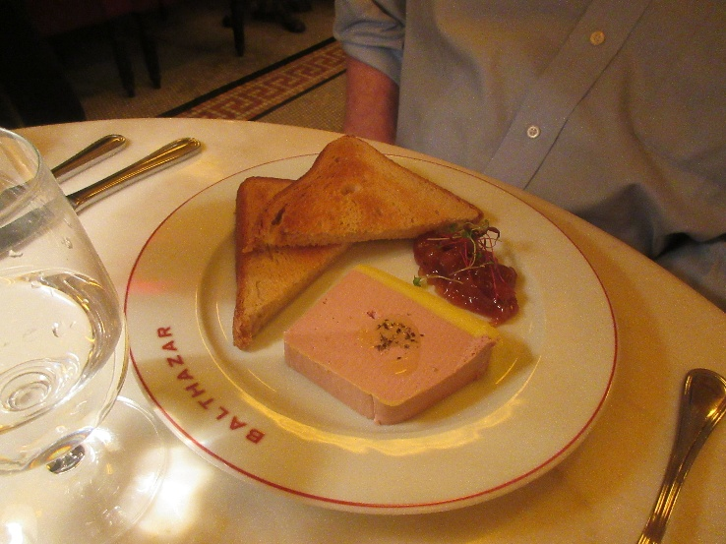
But I digress. We got to have dinner earlier than our reservation, which suited us fine. David, of course, started with the duck liver and cognac parfait, with toasted brioche and house-made pear chutney.
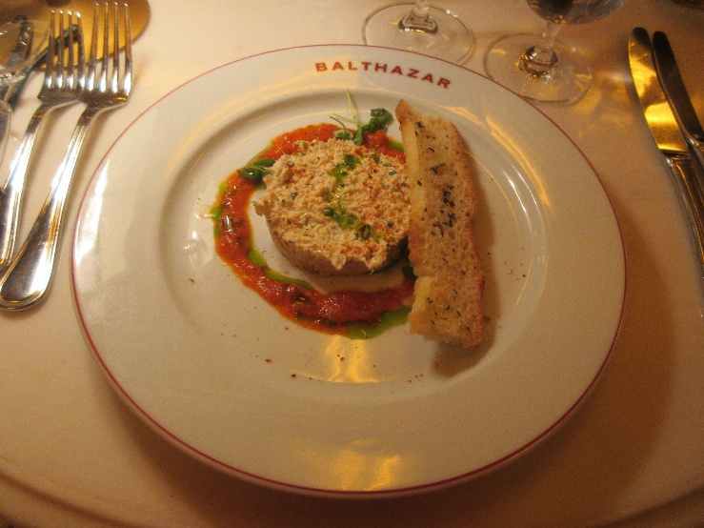

I ordered the hand-picked Devonshire crab with mayo, tomato, and basil.

The we both had the duck confit with Toulouse sausage and cassoulet-style beans.

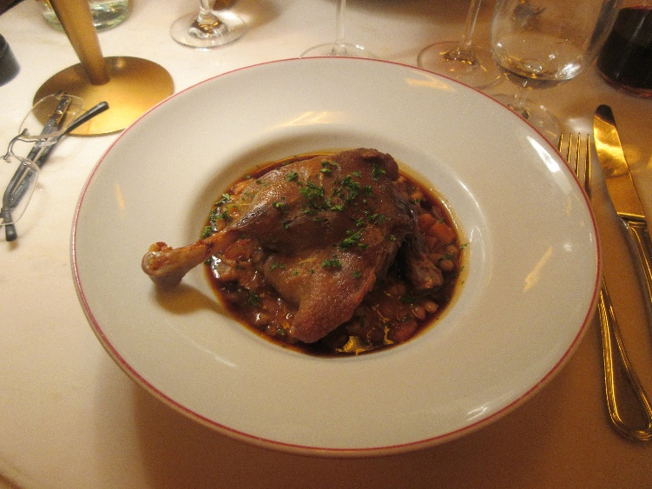
We've had better (in fact, I've made better), but it wasn't bad.

The Paris-Brest with vanilla ice cream and fudge sauce was excellent.
